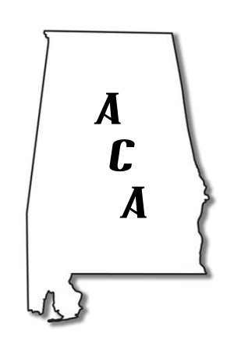
ALABAMA CONTRACTORS ASSOCIATION
An Independent Association of Concerned Contractors and Subcontractors Fighting to Preserve Our Competitive Bid Laws

Say “No” to “No Bid Public Contracts”

PO Box 2354, Montgomery, Alabama 36102-2354

Alabama Contractors Association is working to kill legislation that promotes no bid contracts.

Construction Management at Risk Legislation
Also Know as: Alternative Project Delivery
Construction Manager/ General Contractor

- If this bill passes, an awarding authority will have sole discretion in determining prequalification requirements, thereby allowing the authority to pick whomever it wants to perform a public works project. “The criteria are left to the awarding authority’s and design professional’s discretion….” Page 13, lines 18 & 19 The other words, the CM/GC is hand picked.

- If this bill passes, an awarding authority can choose CM/GC or D-B as the BEST method for a project, regardless of the opinions or objections of anyone else. There is no avenue for protest or appeal. Page 10, line 24 – page 1, line 6.

- If this bill passes, the CM/GC will set the budget and the timeline for the project with no oversight. Page 11, lines 27 – 28.

- If passed, the CM/GC is allowed to self-perform up to 10% of the project - based on a project budget developed by the CM/GC!! Page 14, lines 18 – 23.

- The 10% self-performed maximum does not apply to subcontract work the CM/GC decides to undertake because of “under performance of the subcontractor” or “no subcontract bid received” or “no subcontract bid received within the (GM/GC’s) budget.” Page 15, line 8 – 25.

- If passed, the CM/GC can choose subcontractors to perform work on projects of “ $50,000 or less with or without advertising or sealed bids.” Page 7, lines 25 &27

- The CM/GC sets the subcontractor qualifications, allowing the CM/GC to hand pick “qualified” subcontractors, without competition. Page 17, lines 10 & 11

This bill is anti-small business, anti-minority, anti-free competition and will be detrimental to local contractors, subcontractors and suppliers.

The Alabama General Fund is facing a $250 million shortfall. Passage of this bill would only add to that deficit.

